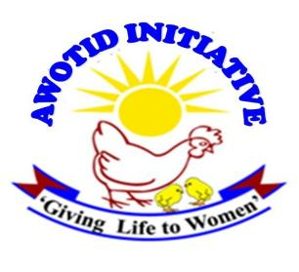
Story 4. Title: Community Advocates Transform Kanu Primary School, in Abim District.
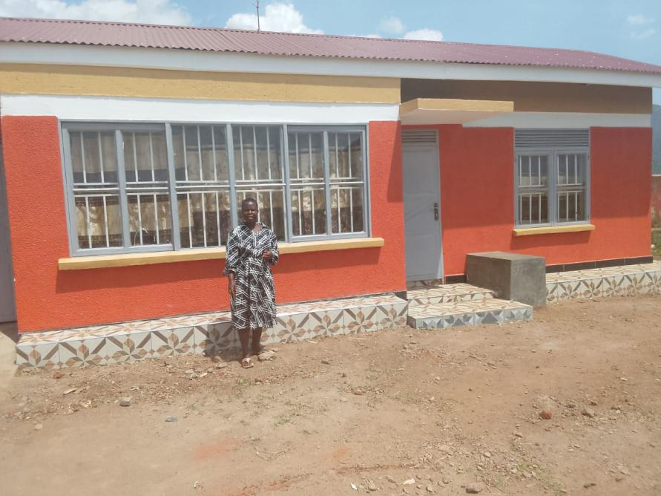
In Abim Sub-County, a vibrant group of women advocates have successfully transformed girls' education by securing a new girls' changing room at Kanu Primary School. Located along the Abim-Agago-Pader road, Kanu Primary is one of the area's oldest and most well-known schools. Before this intervention, many girls regularly missed classes or dropped out entirely due to a lack of private space to manage their menstrual cycles. Motivated by advocacy training from the AWOTID Initiative and KAWUO, group member Sarah Awilli and her team decided they would no longer sit back while local girls suffered.
Immediately following their training, the women launched a strategic campaign by organizing meetings with sub-county teams, local leaders, Parent-Teacher Associations (PTAs), and School Management Committees (SMCs). In November 2025, they officially raised the urgent need for a changing room during a community meeting organized by World Vision. The advocates then systematically followed up with sub-county leadership, pushing them to collaborate with the District Education Officer’s (DEO) office to ensure the request was prioritized and acted upon.
By February 2026, as the new school term opened, the advocates held another critical follow-up meeting. With backing from the DEO's office, sub-county leaders and the Local Council 3 (LC3) successfully lobbied World Vision, an active non-governmental organization in Abim District, to fund the project. Construction began in May 2026. Today, the washroom facility is in its final finishing stages, standing as a direct result of local leaders listening to the community's voice.
Looking forward, Sarah Awilli emphasized that the women's group will continue to support the students beyond just building the infrastructure. They plan to sensitize the girls to carry extra pads during the day and train them on how to make their own sanitary towels. By equipping girls with both the physical space and the practical skills they need, this grassroots initiative will permanently reduce absenteeism, lower dropout rates, and empower young women to stay in school.
“We will ensure the girls are sensitized to carry extra pads when they are in their menstrual cycle, so that they can change during the course of the day, we will ensure they are also trained how to make sanitary towels, so that they don’t have to run back home to change their sanitary towels or miss school when they are in their menstrual cycle.” Sarah Emphasized.

